**MySQL Assignment: Changes to code and why?**

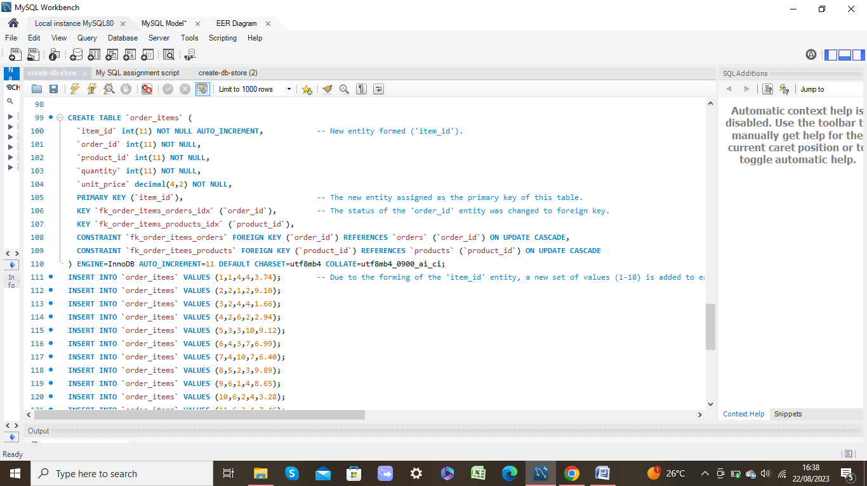**‘order_items’ table code:**

* A new entity was formed called ‘item_id’. This is because initially there were two primary keys found in the code, for this table. The two supposed primary keys however, are entities borrowed from other tables. Therefore, the new ‘item_id’ entity was needed so this table had a unique entity that was not reliant on the existence of another table. Additionally, the ‘item_id’ entity is an identifier entity that will allow data analysts to access specific items more quickly and efficiently. This is so analysts avoid the need to look at the EER diagram and see what relationships the order_items table is reliant on, and see what entity is related to this table that they can use.
* The ‘item_id’ entity was then assigned as the primary key entity of the order_items table. This is mainly due to the fact that it is an identifier entity.
* 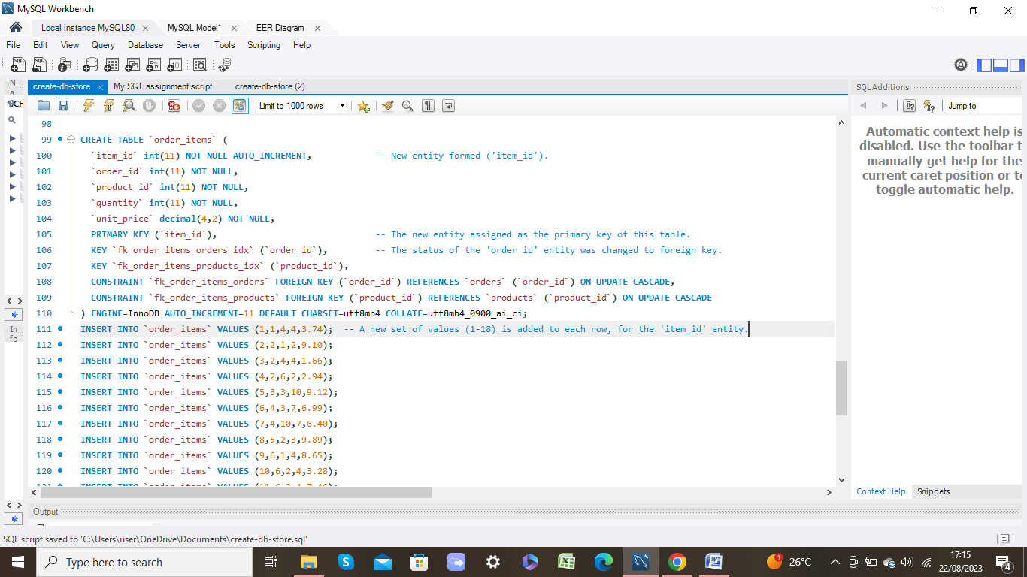With the status of the ‘item_id’ entity is established in this table’s code, this means the status of the ‘order_id’ entity has to be changed from primary key to a foreign key. This is because the ‘order_id’ is a borrowed entity from the orders table.
* A new set of values (1-18) were added into the ‘INSERT INTO...’ part of this table’s code where each item is to be assigned a numerical ID. This is so the analysts can identify each specific item easily.

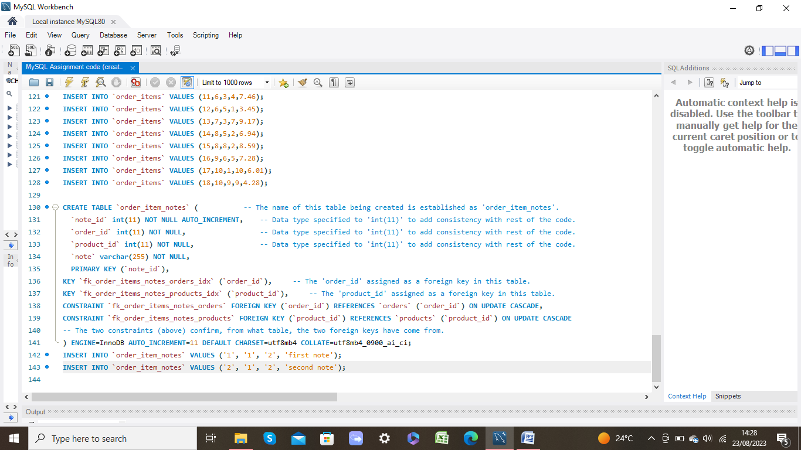**‘order_item_notes’ table code:**

* The ‘sql_store’ name was removed from the code (on line 130) because this name refers to the entire database of this whole code that includes all the other, different tables. It is not a name of a specific table. Therefore, the name for this table is order_item_notes.
* I have specified an integer data type with a precision of 11 for each of the ‘note_id’, ‘order_id’ and ‘product_id’ entities. This is so these 3 entities are represented in the same way as other identifier entities in this code, which will therefore bring some consistency in how the code for identifier entities are written, for this database.
* The ‘order_id’ and ‘product_id’ entities are assigned as foreign keys, in this table.
* The individual constraints are added in the code (for this table) for the ‘order_id’ and ‘product_id’ entities, to confirm they have come from the orders table and products table, respectively.

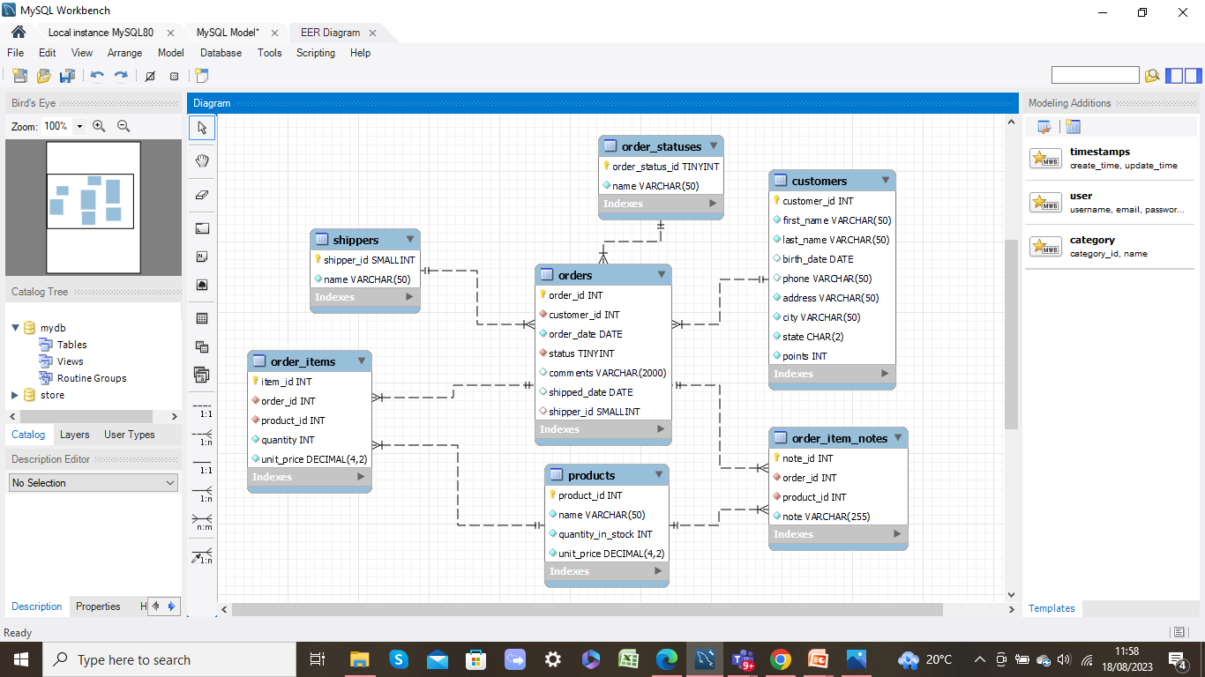**EER diagram:**

By making the changes to the code that were previously mentioned, the results are shown on the EER diagram (above).

* The ‘item_id’ entity appears in the order_items table as a primary key. The ‘order_id’ and ‘product_id’ entities appear as foreign keys in the same table.
* The order_item_notes table appears in the EER diagram as the 7th table in this database.